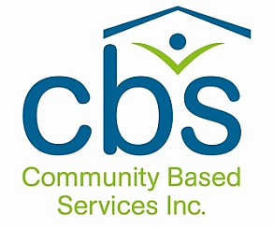

Enriching lives of people with autism and other disabilities

CORPORATE COMPLIANCE
PROGRAM SUMMARY

Administrative Office:
3 Fields Lane
North Salem, NY 10560
914-277-4771
www.commbasedservices.org

Updated: July 2023

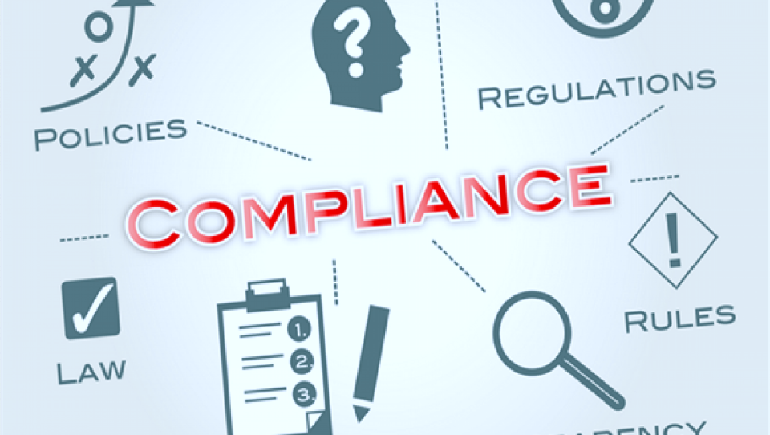

OUR MISSION STATEMENT:

Our mission is to provide each person the best possible quality of life through residential and community-based opportunities.
Our strong, compassionate culture demands that all decisions be made with the person’s involvement and in his or her best interests. This is ensured through an innovative person-centered approach that delivers supports and services based on the specific interests, abilities, and changing needs of each person.
CORE VALUES:

1. The person’s best interest is paramount in all decision making.
2. We create a warm, friendly, and person-centered environment, ensuring that people are safe and that their individual choices are valued and respected.
3. We respect and care for each person by promoting and practicing the “Golden Rule”.
4. We have a caring and compassionate culture. Team members take pride in their work and are committed to a standard of excellence which encompasses innovation, collaboration, and knowledge gained through experience.
5. We provide supports to people that give them the opportunity to fully participate within their community in a manner that fosters personal relationships, independence, choice, fun, and positive individualized outcomes.
6. We are committed to honest, ethical, and fair business dealings with all of our stakeholders.
7. We develop a unified Treatment Team by promoting effective communication, valuing personal contribution, and by embracing and respecting differences.

WHAT IS COMPLIANCE?

The role of compliance is to ensure that Community Based Services adheres to applicable laws, professional best practices, and CBS’ policies and procedures
&
Compliance involves doing ethical work on behalf of the agency and the people we support.

DOING THE RIGHT THING = Truthful, fair, and honest.

WHAT DOES THIS MEAN? COMMITMENT!
We have a Code of Conduct and Ethics for the entire CBS community.
It is the foundation of all organizational policies.

Our code reflects a high level of commitment to:
- Ensuring safety and respect for the people supported, the staff, and the CBS "brand"
- Compliance with the law
- Ethical behavior
- Continuous training and improvement
- Serving CBS in a manner free of conflicts of interest

- Respecting individual and property rights
- Ensuring confidentiality and protecting privacy rights
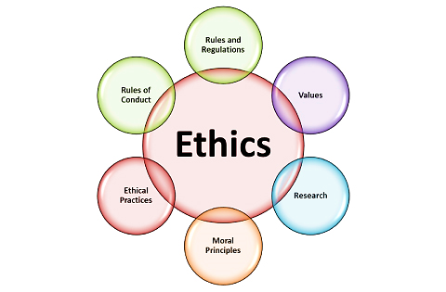

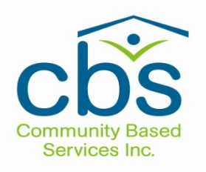
Community Based Services’
Corporate Compliance Policy:
Overall Highlights:
- No person who works for or on behalf of CBS has the authority to act contrary to law, our payer requirements, CBS’ Corporate Compliance Program, policies, or procedures. No one can authorize, condone, or direct violations.

- Persons with knowledge of behavior that violates the law, the CBS code, polices, or procedures are obligated to report.

Accountability and Enforcement:

- Community Based Services maintains “Zero Tolerance” toward illegal and unethical conduct.
- Improper or illegal conduct is never for the benefit of Community Based Services and is strictly prohibited.
- Each person shall be held accountable for violations of the Corporate Compliance Policy.
- Discipline shall be enforced against those affiliated, including managers and supervisors, who fail to detect and/or report wrongdoing.
- Staff cannot, by law, be intimidated or retaliated against for reporting in good faith (these are “Whistleblower Protections”).

COMPLIANCE PROGRAM: OVERVIEW

The Community Based Services Corporate Compliance Program is an agency-wide system designed to detect and prevent violations of law and unethical activities by those associated with the Agency.

The Code of Conduct and Ethics provides all those affiliated with CBS with the information necessary to adhere to the high ethical principles the Agency honors and follows.

WHO MUST COMPLY?

Affiliates & members of the CBS community.
The appointment and retention of all members of the CBS community is contingent upon accepting and complying with this code. This applies to:
1. Volunteers
2. Board members
3. Employees
4. Consultants, vendors, independent contractors and subcontractors impacted by CBS’ risk areas
5. Interns

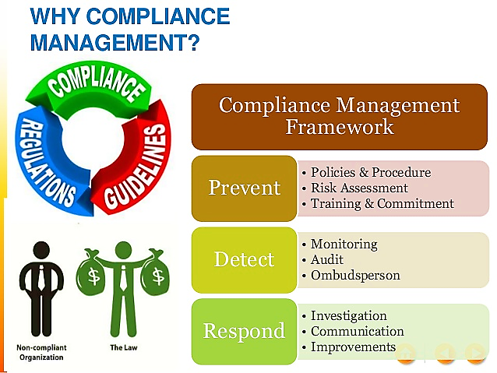

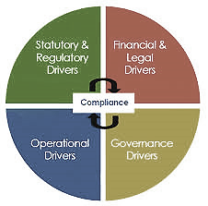
What Drives Compliance?

& Why Are These Drivers Important?

Because we are required to have monitoring activities in place to prevent, detect, and respond to any issue that:

- Could be seen as fraud, waste, or abuse of the public funds (i.e., Medicaid dollars) that allow us to do the work we do.

- Could potentially mean someone is breaking laws or not following our own policies and procedures.

- Might be seen as not being the best practice available for the work we do on behalf of the individuals we support.

- Help us improve our overall management and service delivery processes and systems.

- As trusted and ethical experts in the field, compliance issues can pose a risk to our service and business reputation.

The Compliance Program at
Community Based Services:

The Compliance Program at CBS

The CBS Compliance Program is overseen by the Compliance Officer who:
- Chairs the compliance committee,
- Creates and oversees an annual compliance work plan,
- Acts with support as advisor, investigator, and risk manager for the agency,
- Acts as the HIPAA Privacy Officer and collaborates with the agency’s HIPAA Security Officer.

The role is supported by the CEO and Board of Directors.

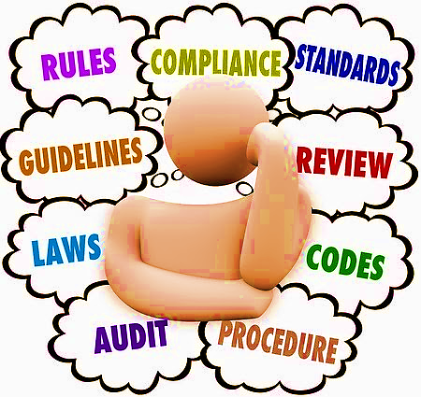

Our Compliance Program - Eight Core Elements:

- Written policies and procedures
- Designated employee vested with responsibility for the Compliance Program (the Compliance Officer)
- Training and education
- Lines of communication to the responsible compliance position [the Compliance Officer]
- Disciplinary policies to encourage good faith participation
- A system for routine identification of compliance risk areas
- A system for responding to compliance issues
- A policy of non-intimidation and non-retaliation

Examples of CBS’
Compliance Program Activities
The following illustrates some of the work of the Compliance Program at CBS. Many are scheduled and incorporated into the Compliance Work Plan. Others are conducted as needed or required in response to day-to-day risk detection, prevention, and management efforts that strengthen overall compliance by CBS.

- Monitor and respond to Compliance Hotline calls
- Develop/update compliance policies and procedures
- Create and conduct compliance training events across programs and administrative areas
- Train on new regulations and laws
- Act as advisor to the Chief Executive Officer, Board, and senior leadership on corporate-wide compliance concerns
- Complete independent investigations of situations that pose a risk for Medicaid abuse, fraud, and/or waste
- Complete Medicaid billing and service compliance “look-backs” (internal auditing to validate paid billing claims for monies already received by CBS)
- Assist with addressing Medicaid overpayments (in collaboration with the Finance Department)

- Review and investigate issues or situations that pose a risk of violating privacy rules under HIPAA
- Complete HIPAA Security monitoring (with the CBS Information Technology Manager/HIPAA “Security Officer”)
- Complete quarterly HIPAA privacy risk monitoring at program and office locations
- Complete federal HIPAA breach reports each year
- Assess the compliance program each year using NYS standards
- Monitor remediation & corrective action efforts
- Communicate with leadership, including compliance and quality improvement trending.

Potential Compliance Violations

The following are just a few examples of compliance and/or ethical concerns that could arise and should be reported:

Agency assets & resources, such as office supplies, equipment, vehicles, and property, may not be used for any reason other than to the benefit of CBS or its affiliates.

Other examples of assets/resources are copiers, scanners, credit cards, computer/network accounts, office supplies, residential supplies, gas cards, tools and equipment, cell phones, vendor accounts.

Running personal errands on “work time” is another example of misuse of an agency resource (time).

Any misuse or misappropriation of agency funds, information, equipment, facilities, or other assets/resources may be considered criminal behavior and can result in severe employment and legal consequences.

More Information You Need To Know:

CBS receives most of its program funding by billing Medicaid. Compliance must monitor for and help prevent any Medicaid waste abuse, or fraud.

1: What does Medicaid consider as fraud, waste, or abuse?

Fraud = An intentional deception or misrepresentation that the individual knows to be false & knows that the deception could result in some unauthorized benefit (A provider intentionally submits a claim for a service that was never provided)

Waste = Inappropriate or inefficient use of Medicaid funds and resources

Abuse = Acts to provide information to the government that causes CBS to receive higher payments than to which it is entitled.
With abuse, these acts can be unintentional, but might reflect poor system controls that must be addressed (failure to do so then has the potential of being viewed not as abuse, but as intentional acts [or fraud] by providers like CBS).

2: How do we provide services in compliance with what Medicaid wants?

For all services we deliver, we follow the rules for the Medicaid Home and Community Based Services (HCBS) Waiver programs. Similar to medical services, CBS has to have a “prescription” on file for each person we support that names us as the service provider. The Life Plan acts as that prescription for each waiver service provided.
At CBS, we are assigned to provide a staff action plan for the HCBS Waiver services we offer. HCBS at CBS include:
- Residential Habilitation (Supervised IRAs)
- Day Habilitation (site-based or “without walls”)
- Community Habilitation
- Respite
- Supported Employment

Each program type has a variety of regulations/standards that CBS must meet. Virtually all compliance requirements for each service a person receives begins with the first day we provide a service. Any standard not met poses a risk of CBS being out of compliance (and any payments received for the service(s) in some cases must be “disallowed” and returned to Medicaid).

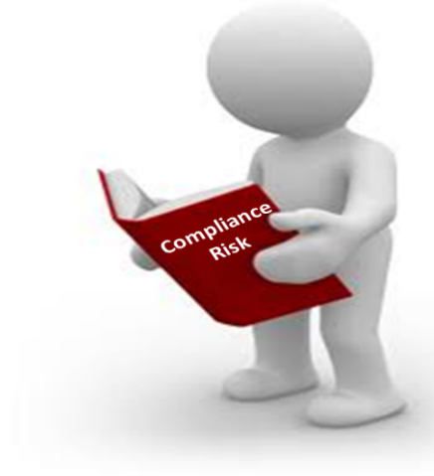
*All services must be provided as stated in each
person’s staff action plan - as part of
the person-centered planning process. This process is
facilitated by the individual, family advocates, care manager,
and other members of the service planning team.

And 3: What is required to successfully bill for services and get paid by Medicaid?
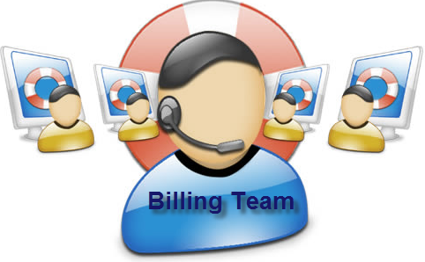

For all services we deliver, we follow the rules for billing Medicaid. This is conducted by the Finance Department and program services staff. All billing documents must contain specific program information on the services provided. This may include – but is not limited to:
- The date each service was provided
- What action staff took and the person’s response
- The name and title of staff who provided the service
- Progress notes (monthly summaries) describing overall - the actions of staff, the person’s response to the staff actions, and any issues and/or concerns.
- The correct billing codes used by the Finance Department.

(Documentation requirements for on-going service compliance can vary for each of the different habilitation services we offer. Training and clarification are provided to responsible staff continually at CBS).

SPECIAL NOTE FOR STAFF AT CBS:

All services are to be entered into the electronic system used by CBS (eVero)

In the event services must be documented manually on paper, the correct form must be used, and all entries must be legible and complete. If errors occur, staff must make corrections using a single line through the incorrect information, write their initials and date, and enter the correct information (scribbling over or using ‘white out’ is not permitted).

Also, Medicaid cannot be double billed. This could be considered Medicaid abuse or fraud. For example:

- Billing for time at a medical appointment during day program hours

- Billing for residential habilitation and day habilitation service for the same time period

- Billing for day program and supported employment services for the same time period

REPORTING COMPLIANCE CONCERNS
The Corporate Compliance Program affects all employees, volunteers, Members of the Board of Directors and consultants, vendors, independent contractors and subcontractors impacted by CBS’ risk areas.
If you have a compliance concern or complaint, you have several ways to communicate it with us. Contact:
- Your supervisor or another supervisor in the chain of management

- The Human Resources Department (e.g., for general workplace issues)

- The HIPAA Security Officer (Jared Ponzini) for suspected violations related to CBS’ email, networks, and/or computer systems

- The Compliance Officer (and HIPAA Privacy Officer), Melissa Zambri at 914-277-4771, ext. 106

- By email to mzambri@commbasedservices.org

- In writing by USPS mail in an envelope marked “confidential” to: Compliance Officer, Community Based Services - Administrative Office, 3 Fields Lane North Salem, NY 10560

G. In person with the Corporate Compliance Officer, or

- The Compliance/Whistleblower Hotline at 914-277-4771, ext. 110 (anonymous reporting method, all reporting is protected from intimidation and retaliation).

The Compliance/Whistleblower Hotline will not be answered by a person. It allows a caller to report their concerns/violations by leaving a message. All messages will be forwarded to the Corporate Compliance Officer.

If leaving a message on the Hotline,
your message should include:

- The department, location, program, and/or site of the compliance issue
- A description of the compliance issue/situation
- The name and/or title of the person, as known, who is believed to be involved in the compliance violation
- How other people may be involved in the violation – if applicable
- Callers have the option to leave a name and contact information for follow up
- All reports will be investigated, and corrective action will be recommended as applicable.

ANY QUESTIONS?
Contact:
Melissa M. Zambri, Esq.
Corporate Compliance Officer
Community Based Services, Inc.
3 Fields Lane, North Salem, NY 10560
914-277-4771 x 106
mzambri@commbasedservices.org
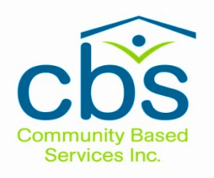

Thank you for supporting the Compliance Program at Community Based Services, Inc.

